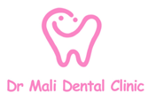

64 Fulham High Street, London, SW6 3LQ

Tel: 02080505411

**Please kindly fill the form and email it to “info@drmalidental.co.uk”**

|  |  |
| --- | --- |
| Patient’s Full Name |  |
| DOB |  |
| Gender |  |
| Contact number |  |
| Email Address |  |
| Home address |  |
| Medical History |  |
| Medications |  |
| Referral reason |  |
| Referrer name, address, contact number and email address |  |